Georgia Council on Developmental Disabilities

Application for Membership

Completion of this form is a requirement to apply for appointment to the Georgia Council on Developmental Disabilities. Information submitted on this form may be subject to public disclosure under the Georgia Open Records Act (O.C.G.A. 50-18-70).

Georgia Council on Developmental Disabilities (GCDD)
Sloppy Floyd Building, West Tower 200 Piedmont Avenue SE Suite 426, 4th Floor, Atlanta, GA 30334
Attention: D’Arcy Robb

If you have any questions or need support completing your application, please call (404) 657-2126 or 1-888-275-4233 or email Eric Foss at Eric.Foss@gcdd.ga.gov

Section I: Biographical Information

Full Name

First Name

Middle Initial

Last Name

Residence Address

Street Address 1
Street Address 2

City

State

Zip Code

Mailing Address (if different from Residence Address)

Street Address 1
Street Address 2

City

State

Zip Code

E-mail address

Birthdate (mm/dd/yyyy)

Race/Ethnicity (Pick from drop down menu):

Gender

Geographical Information

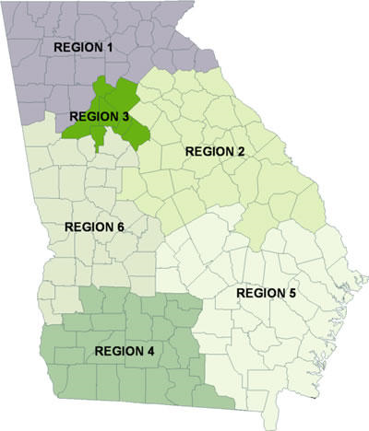
What area of Georgia do you live in?

Please check your region based on the map:

1 – North Georgia
2 – East Central Georgia
3 – Metro Atlanta
4 – Southwestern Georgia
5 – Southeastern Georgia
6 – West Central Georgia

Section II: Relationship to People with Developmental Disabilities

Developmental disability is defined as: a significant, chronic disability that begins before age 22 and is likely to continue throughout life.

A developmental disability has a major impact on the person’s life in at least 3 of the following areas:

- Self-care
- Language
- Learning
- Mobility
- Self-direction
- Capacity for independent living
- Economic self-sufficiency

Please select all that applies:

I am a Georgia Resident with a developmental disability.

Please tell us how your disability impacts you.

Have you ever lived in an institution, or do you live in one now?
Institution means a place that provides food, shelter, and some treatment or services to four or more people not related to the administrator.

Yes No I am not sure.

(cont.)

I am a Parent, Family Member, or Legal Guardian of a Georgia Resident (under age 18) with a Developmental Disability.

Please tell us how the child’s disability impacts them.

Has the child with a developmental disability ever lived in an institution, or do they live in one now? Institution means a place that provides food, shelter, and some treatment or services to four or more people not related to the administrator.

Yes No I am not sure.

I am a Parent, Family Member, or Legal Guardian of a Georgia Resident (18 or older) with a Developmental Disability.

Please tell us how your adult relative’s disability impacts them.

Has your adult relative ever lived in an institution, or do they live in one now?
Institution means a place that provides food, shelter, and some treatment or services to four or more people not related to the administrator.

Yes No I am not sure.

I am representing a non-government organization or nonprofit. Please specify the organization or agency you are representing. (Note: if your application is selected for membership, membership will be in the name of the organization or agency, rather than a specific individual.)

Name of organization or nonprofit:

How does your organization support people with developmental disabilities in Georgia?

Is this organization:

A Non-Governmental Organization (NGO) – defined as an organization not under Government control, that according to federal law cannot be religious or military in nature.

A nonprofit organization – defined as a private non-profit with a voluntary board

Both a non-governmental and non-profit organization

Section III: Membership to the Georgia Council on Developmental Disabilities

If you are applying on behalf of an organization, please substitute “your organization” for “you” in the questions below.

Does your employer receive funds from GCDD? Yes No

If yes, what is your job title?

Have you ever served on the Council? Yes No

If you have, when did you serve on Council?

Why do you want to become a member of the Georgia Council on Developmental Disabilities?

What strengths do you bring to the role of council member?

What is your experience with improving the lives of people with developmental disabilities? This may include volunteer experience, advocacy, and any work with community.

What are your ideas to improve the lives of Georgians with developmental disabilities and their families?

Do you require any accommodations to participate as a Council member? If yes, describe accommodations needed (accessible transportation, personal care provider, interpreter, facilitator, special dietary requirements, etc,)

Section IV: Signature

I understand that any information obtained by a personal history background investigation which is developed directly or indirectly, in whole or in part, upon this release authorization will be for use by the Georgia Council on Developmental Disabilities in determining my suitability for appointment to the Georgia Council on Developmental Disabilities.

Applicant’s Full Name Printed

Applicant’s Signature ______________________

Date

Completed applications can be sent in the following ways:

By mail:

Georgia Council on Developmental Disabilities (GCDD)
Sloppy Floyd Building, West Tower 200 Piedmont Avenue SE
Suite 426, 4th Floor
Atlanta, GA 30334
Attention: D’Arcy Robb

By email to membership@gcdd.org with “Council Member Application” in the subject line.
If you have any questions or need support completing your application, please call (404) 657-2126 or 1-888-275-4233 or email Eric Foss at Eric.Foss@gcdd.ga.gov or membership@gcdd.org

